Application Of Dempster Shafer Method To Diagnose Disease In Sugarcane Plant

Dewi Novika Simanjuntak, Fristi Riandari,

Informatics Engineering, STMIK Pelita Nusantara, Sumatera Utara, Indonesia
Article Info |  | ABSTRACT
Article history:  Received: 03/10/2021  Revised: 22/ 10/2021  Accepted: 03/11/2021  Available online 01/12/2021 |  | Sugarcane is a very important and agrarian plantation product in Indonesia, because sugar cane is a producer of sugar. However, in its cultivation, several problems often occur, such as diseases in sugarcane plants where when sugarcane plants are attacked by disease and are not handled, farmers will experience crop failure. Based on this, a tool is needed in the form of an expert system to diagnose diseases in sugarcane plants. The method used in this study is the Dempster Shafer method which processes data by providing evidence based on the belief funcation and plausible value of each symptom. This study treats 4 types of disease with 13 symptoms. The results showed that the dempster shafer method can be used as a tool in diagnosing sugarcane plant diseases so that it is expected to help farmers in handling diseases that attack sugarcane plants quickly and precisely and can increase profits from sugarcane harvests for farmers.
Keywords:
Sugarcane,
Expert System,
Dempster Shafer
Keywords:  Sugarcane,  Expert System,  Dempster Shafer |  | This is an open access article under the CC BY-NC license.  
Corresponding Author:
Fristi Riandari,
Informatics Engineering,
STMIK Pelita Nusantara Medan,
Jl Iskandar Muda No. 1 Medan, 20154, Indonesia.
Email: fristy.rianda@ymail.com

- Introduction

Us in solving all the problems and difficulties that we experience .. One useful phase The development of technology in the current era is very sophisticated and fast. Sophistication of technology today has helped a lot in technological development, namely the emergence of the industrial revolution 4.0, with the existence of information technology when needed in the plantation sector. One of the fields of technology is the application of expert systems. An Expert System is a knowledge-based program that provides expert-quality solutions to problems in a specific domain.
The limitations of an expert in diagnosing a disease require an expert system to solve the problem. As for the method used, the Dempster Shafer method is a mathematical theory for proof based on belief functions and plausible reasoning (for beliefs and thoughts that enter ideas), which are used to combine separate pieces of information (facts) to calculate the probability of an event” [2].
One of the plants developed in the sugar cane plant is a producer of sugar. Sugar in the Indonesian economy has a very useful role, because sugar is one of the basic needs that Indonesian citizens need. To reduce the risk of sugarcane disease, we need a system that has the expertise of an expert in diagnosing the disease.
In previous studies using the same method, namely the Dempster Shafer with the title of the research "Implementation of the Dempster Shafer Method in Expert Systems for Web-Based Diagnosis of Tropical Disease Infections" [3]. In this study, it was concluded that the Dempster Shafer method had been successfully used to diagnose tropical disease infections and the success rate of system testing using 104 medical record sample data was 94.23%. in a subsequent study entitled "Implementation of the Dempster Shafer Method for Diagnosing Diseases of Rice Plants" The implementation of the Dempster Shafer method has been successfully used and can provide information about the type of disease, symptoms and preventive solutions. Based on the test results, the accuracy of 20 test cases using the density of symptoms that came from experts resulted in an accuracy of 90% [4]. And further research with the title "Using the Dempster-Shafer Method as the Basis of an Expert System for Diagnosis of Sugarcane Diseases Based on a Web" The conclusion of this study is as follows this system can provide information about sugarcane disease, symptoms, causes, descriptions, treatment methods and pictures of the disease , the results of the diagnosis and the percentage value are most likely obtained using the dempster-shafer method based on the tests that have been carried out in the expert testing process, obtained an average accuracy of 96.86% so that it can be concluded "the system can identify very well. previous research with the title Dempster Sharfer Method on an Expert System for Diagnosing Stomach Disease" the results of the test, it can be concluded that the accuracy of the expert system based on the 30 data tested is 93.33% which indicates that this expert system can function properly according to the diagnosis from the expert. [16]. The inaccuracy of the expert system is 6.67% which is caused by several possibilities, including errors in giving symptom confidence values ​​for each disease, errors in applying calculation methods or errors in entering symptom information in each disease [2]. Subsequent research with the title "Expert System Modeling for Identification of Sugarcane Pest Diseases with the Dempster-Shafer Method" In the 23rd case type of disease there was a difference in identification where expert data identified downy mildew, while the system results identified smut disease. The disease resulted in a density value of 0.567 or 56.7%. In the 24th case type of disease there was a difference in identification where expert data identified chlorosis line disease, while the system results identified blendok disease. The disease produces a density value of 0.567 or 56.7%[11].
So that the purpose of this study is to produce information in diagnosing diseases in sugarcane plants.

- Method

- Research Framework
In this study, there is a research framework which is the stages carried out in completing research or writing a thesis

System Planning
Identify the problem
Set goals

Collecting Data

Implementation of sharper’s dempster method

System Implementation
System Testing

Method Analysis

Figure 1. Research Framework

- Description of the Framework
This research method applies a research framework consisting of problem identification, goal setting, method analysis, data collection, implementation of the Dempster Sharfer method, system design, system implementation, and system testing.
the work of the Dempster Shafer method in carrying out the diagnosis of sugarcane disease.
- Collecting data
Gathering information by interviewing experts and carrying out direct observations at the research site and direct observation of knowledge or information about diseases in sugarcane plants, in order to obtain the data and information needed such as physical data on symptoms and types of diseases experienced by sugarcane plants.
- Implementation of the Dempster Shafer Method
After the information is collected, data processing will be carried out to adjust the data activities to be processed using the Dempster Shafer method. To calculate the value of Dempster Shafer disease in sugarcane, the selected sugar cane uses a predetermined believe value for each symptom. Where the value of the bell (believe) is the weight value inputted by the expert.
- System planning
Database system design, making diagrams and flowcharts, data design, and interface design.
- System Implementation
The information in this session is processed and the facts or conditions (rules) that have been obtained will be processed with a system that has been created and has been designed so as to produce knowledge of disease information and the percentage of certainty of results.
- System Test
In this session, a check will be made on the system that has been built using existing data. The results of this check are then used as the basis for making the necessary improvements to produce the system as expected.

- Results and Discussion

In designing this expert system, taking sources from experts or experts, books and design journals will be based on VB which is useful for detecting diseases using the Dempster-Sharfer method.
- Data Analysis
- Type of disease
The following describes the types of sugarcane plant diseases, totaling 4 diseases along with the disease code.
The following is a list of types of diseases in sugarcane:

TABLE 1.
Types Of Disease
No | No ID Disease | Name Disease
1 | P01 | Pokahbung disease
2 | P02 | Pokahbung disease
3 | P03 | Vascular Disease (Ratoon Stunting Disease)
4 | P04 | Fire Wound Disease

- Symptoms of Disease in Sugarcane Plants
The following describes the symptoms of sugarcane disease, which are 13 symptoms along with their symptom codes.
Here are the symptoms on sugarcane plants that are attacked by the disease:

TABLE 2.
Symptoms
No | Symptom Code | Symptom | P01 | P02 | P03 | P04 | Density Value
1 | G1 | New leaf blade  open, the base looks chlorotic or red dots and lines | √ | - | - | - | 0,75
2 | G2 | On young stems, brownish red stripes appear and growth of stem tips is stunted. | √ | - | - | - | 0,60
3 | G3 | There is rotting of the tip of the shoot with an unpleasant odor. | √ | - | - | - | 0,45
4 | G4 | In the hollow part the stem is bent and slightly flattened. | √ | - | - | - | 0,42
5 | G5 | There is damage to the shoots or shoots die. | √ | - | - | - | 0,49
6 | G6 | The appearance of light green elongated spots, especially on young leaves. | - | √ | - |  | 0,75
7 | G7 | On the stems of sugarcane plants, there are irregular white lines | - | √ | - | - | 0,60
8 | G8 | Plants are stunted and Plants are stunted. | - | - | √ | - | 0,80
9 | G9 | If the stem is split longitudinally there is a reddish-orange coloration in the form of dots or commas on the lower segment. | - | - | √ | - | 0,50
10 | G10 | The youngest leaves turn into a round, whip-like shape, black in color, about the size of a pencil. | - | - | - | √ | 0,75
11 | G11 | The diameter of the cane stem is reduced. | - | - | - | √ | 0,45
12 | G12 | Leaves small and narrow. | - | - | - | √ | 0,45
13 | G13 | Sugarcane tiller growth is fast and abundant but unhealthy (sugar cane looks like grass). | - | - | - | √ | 0,42

To determine the disease that is attacking sugarcane plants, calculations are carried out with the following example:
There is a farmer who cultivates sugar cane, where his sugarcane plant is suspected of being infected with an unknown disease. Then farmers conduct consultations to answer questions about the symptoms of diseases in sugarcane that occur in the cultivator's plants, namely as follows:
Symptom Code List of Questions Regarding Symptoms of Pest Diagnosis on Sugarcane Plants Selected Answers

TABLE 3.
Symptom Code List of Questions Regarding Symptoms of Pest Diagnosis on Sugarcane Plants Selected Answers
Symptom Code | List of Questions Regarding Pest Diagnosis Symptoms on Sugarcane Plants | Selected Answer
G1 | Leaf blade that has just opened, the base looks chlorotic or red dots and stripes | Yes
G6 | The appearance of light green elongated spots, especially on young leaves | Yes
G7 | G7 On the stems of sugarcane plants, there are irregular white lines | Yes

Based on the 3 cases, there were 3 selected symptoms, namely G1, G6, G7. Where G1 is a symptom of Pokahbung disease (P01) and G6, G7 is a symptom of Mosaic disease (P02), then the percentage of possible diagnoses will be sought.
Symptom 1: G1
G1 is a symptom of a disease in sugarcane plants that is diagnosed at P01 (Pokahbung Disease) then:
Belief : m1{P01}= 0.75
Plausibility : m1(θ) = 1 - 0.75 = 0.25
Symptom 2: G6
G6 is a symptom of a disease in sugarcane that is diagnosed at P02 (Mosaic Disease) then:
Belief : m2{P02}= 0.75
Plausibility : m2(θ) = 1 - 0.75 = 0.25
Then we get the combination rule of m1{P01} with m2{P02}

TABLE 4.
Then we get the combination rule of m1{P01} with m2{P02}
m2  m1 | P02 = 0.75 | θ = 0.25
P01 = 0.75 | {P01, P02}  = 0.75* 0.75 = 0.5625 | {P01}  = 0.75 * 0.25= 0,1875
θ= 0.25 | {P02 }  = 0.25* 0.75 = 0.1875 | (θ)  = 0.25 * 0.25 = 0.0625

From the results of the combination of the tables obtained the value of m3:

$m3(P01)=\frac{0.1875}{1-(0,5625)}$= 0.428571429

$m3(P02)=\frac{0.1875}{1-(0,5625)}$= 0.428571429

$m3\left(θ\right)=\frac{0.0625}{1-(0,5625)}$= 0.142857143

Symptom 3: G7
G7 is a symptom of a disease in sugarcane that is diagnosed at P02 (Mozaic Disease) then:
Belief : m4{P02}= 0.60
Plausibility : m4(θ) = 1 - 0.60= 0.40

Then we get the combination rule:

TABLE 5.
Then we get the combination rule
m4  m3 | P02= 0.60 | θ= 0.40
P01= 0.428571429 | { θ }  = 0.428571429*0.60 = 0.257142857 | {P01}  0.428571429*0.40= 0.1714
$P02$= 0.428571429 | {P02 }  = 0.428571429*0.60= 0.257142857 | {$P02$}  0.428571429*0.40= 0.1714
θ= 0.142857143 | {P02 }  0.142857143*0.60= 0.085714286 | (θ)  = 0.142857143*0.40= 0.0571

From the results of the combination of the tables obtained the value of m5:

$m5\left(P01\right)=\frac{0.1714}{1-0.257142857}$=0.231

$m5\left(P02\right)=\frac{0.257142857+0.085714286+0.1714+}{1-0.257142857}$= 0.692

$m5\left(θ\right) =\frac{0.0571}{1-0.257142857}$ = 0.077

So, P01 = 0.231 x100% = 23.1%

P02= 0.692 x 100% = 69.2%

After doing the calculations, the results obtained are the values ​​of 2 diseases, namely P01 (Pokahbung Disease) with a value of 23.1% and P02 (Mosaic Disease) with the largest value of 69.2%. Where the highest value is in Mosaic Disease or P02 with a value of 69.2%. So the conclusion from the Dempster Shafer calculation is: "The disease that attacks the sugarcane plant belonging to the farmer is Mosaic Disease with a percentage rate of 69.2%".

TABLE 6.
Presentation/Certainty Range Value
Presentation of Density Value | Description
76% - 100% | Sure
51% - 75% | Pretty Sure
26% - 50% | Most Likely
≤ 25% | Chance

- System Design and Implementation
The steps in designing the system using UML are in the form of use case diagrams. Use case diagram is a technique used in the development of a software or information system to capture the functional requirements of the system in question.

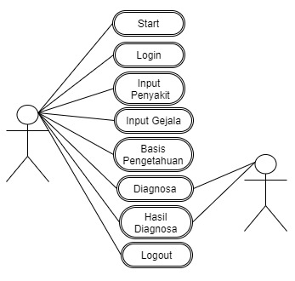
Figure 2. Use Case Diagram

After applying the dempster sharfer method, a system is implemented that functions to display the results of the expert system program to diagnose sugarcane plant diseases.
- Main Menu Form
Main Menu Form is used as a liaison for Data Input Form, Diagnosis Form and Exit Button which aims to end the program as a whole

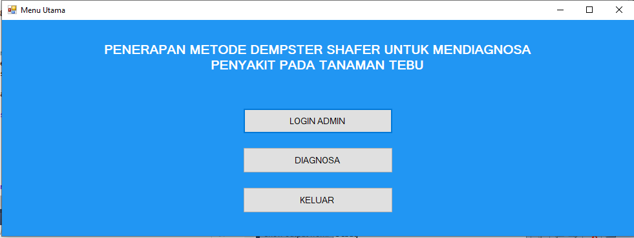
Figure 3. Menu Form

- User Report Form
User Report Form is the final result of diagnosis on sugar cane which displays the results in the form of user reports that can be printed.

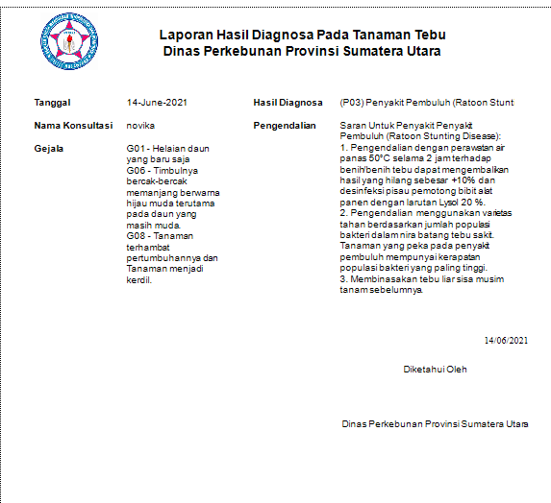
Figure 4. User Report Form

- Conclusion

Based on the analysis of the problems that occurred in the cases raised about sugar cane using the Dempster Shafer method, it can be concluded that the expert system for diagnosing diseases in sugar cane using the Dempster Shafer method was designed starting with needs analysis, then modeling. UML modeling is described in the form of Use Case Diagrams, Activity Diagrams, and Class Diagrams. Based on the results of previous studies, the Dempster Shafer method can be applied in a system to properly diagnose diseases in sugarcane. There are 3 things that are very important so that expert knowledge can be processed using the Dempster Shafer method and run well on the Microsoft Visual Studio 2010 programming language application, namely symptom data, disease data, and knowledge base data. Based on this, the system that adopts the implementation of the Dempster expert Shafer can be used to solve problems regarding diseases in sugarcane very well. The final results of the diagnosis issued are in accordance with the data

References

[1] R. Hariyanto and K. Sa’diyah, “Sistem Pakar Diagnosis Penyakit dan Hama Pada Tanaman Tebu Menggunakan Metode Certainty Factor,” JOINTECS (Journal Inf. Technol. Comput. Sci., vol. 3, no. 1, pp. 1–4, 2018, doi: 10.31328/jointecs.v3i1.500.
[2] D. Ayu and N. Wulandari, “Metode Dempster Shafer Pada Sistem Pakar Untuk Mendiagnosa Penyakit Perut,” Agustus, vol. I, no. 2, pp. 235–244, 2015.
[3] R. Setiawan, C. Suhery, and S. Bahri, “Implementasi Metode Dempster Shafer Pada Sistem Pakar Diagnosa Infeksi Penyakit Tropis Berbasis Web,” J. Coding, vol. 06, no. 03, pp. 97–106, 2018.
[4] S. Orthega, N. Hidayat, and E. Santoso, “Implementasi Metode Dempster-Shafer untuk Mendiagnosa Penyakit Tanaman Padi,” J. Pengemb. Teknol. Inf. dan Ilmu Komput., vol. 1, no. 10, pp. 1240–1247, 2017.
[5] S. Jodi, D. Arifianto, and A. Nilogiri, “Aplikasi diagnosis penyakit tanaman tebu menggunakan metode forward chaining,” 2017.
[6] M. Orisa, “Aplikasi Sistem Pakar Diagnosis Penyakit Tebu Menggunakan Metode Certainty Factor Berbasis Web,” pp. 265–272, 2016.
[7] A. Ayu and N. A. Hasibuan, “Diagnosa Penyakit Sepsis,” KOMIK (Konferensi Nas. Teknol. Inf. dan Komputer), vol. I, pp. 154–160, 2017.
[8] J. N. Sitompul, J. D. M. Saragih, and A. M. H. Pardede, “SISTEM PAKAR KONSELING SISWA SMA,” vol. 6, no. 1, 2021.
[9] I. L. K. Panjaitan, “Analisis Perbandingan Metode Dempster Shafer Dengan Metode Certainty Factor Untuk Mendiagnosa Penyakit Stroke,” J. Inform. Pelita Nusant., vol. 3, no. 1, pp. 69–74, 2018.
[10] R. Pane, M. Nasution, and D. Irmayani, “Penerapan Metode Dempster Shafer Untuk Mendiagnosa Penyakit Liver,” Informatika, vol. 8, no. 3, pp. 121–131, 2020, doi: 10.36987/informatika.v8i3.1831.
[11] Y. Nurcahyo, N. Hidayat, and R. S. Perdana, “Pemodelan Sistem Pakar untuk Identifikasi Hama Penyakit Tanaman Tebu dengan Metode Dempster-Shafer,” J. Pengemb. Teknol. Inf. dan Ilmu Komput. Univ. Brawijaya, vol. 2, no. 3, pp. 1187–1193, 2018.
[12] Verawati and P. D. Liksha, “Aplikasi Akuntansi Pengolahan Data Jasa Service Pada Pt. Budi Berlian Motor Lampung,” J. Sist. Inf. Akunt., vol. 1, no. 1, pp. 1–14, 2018.
[13] A. R. Ruli, “Implementasi Aplikasi Pendaftaran dan Pembayaran Kontrakkan Ahmad Rais Berbasis Desktop VB Net dan Microsoft Access,” Paradigma, vol. 19, no. 1, pp. 9–19, 2017.
[14] F. Latif and aditya wirangga Pratama, “Perancangan Sistem Informasi Manajemen Arsip Elektronik,” J. Akuntansi,Ekonomi dan Manaj. Bisnis, vol. 3, no. 1, pp. 21–31, 2015, [Online]. Available: https://jurnal.polibatam.ac.id/index.php/JAEMB/article/download/180/168.
[15] A. Shany, D. M. Khairina, and S. Maharani, “Sistem Informasi Evaluasi Akademik Mahasiswa (Studi Kasus Program Studi Ilmu Komputer Fakultas Matematika Dan Ilmu Pengetahuan Alam Universitas Mulawarman),” Inform. Mulawarman J. Ilm. Ilmu Komput., vol. 11, no. 1, p. 37, 2016, doi: 10.30872/jim.v11i1.201.
[16] M. M Pratama, M. Yusman, S. R. D, and F. E. Febriansyah, “Penggunaan Metode Dempster-Shafer Sebagai Dasar Sistem Pakar Diagnosis Penyakit Tebu Berbasis Web,” J. Trop. Upl. Resour., vol. 02, no. 02, pp. 259–268, 2020, [Online]. Available: https://doi.org/10.23960/jtur.vol2no2.2020.110.

